FIVB INTERNATIONAL TOP ATHLETES’ PARTICIPATION IN NATIONAL TOURS REQUEST

FIVB INTERNATIONAL ATHELTE’S PARTICIPATION AGREEMENT
in case of a clash with an FIVB Beach Volleyball events

This form must be filled in for each athlete and sent to the FIVB by his/her NF duly signed by all parties for the participation of any top 64 ranked athlete in the individual ranking of each gender in a foreign homologated National Tour leg clashing with a Volleyball World Beach Pro Tour even
VB/Volleyball World Beach Pro Tour World Championships, Volleyball World Beach Pro Tour Finals, FIVB Beach Volleyball Under - Age World Championships, at least 30 days before the event, regardless if he/she is already registered and eligible to take part in the FIVB/Volleyball World for an FIVB/Volleyball World Beach Volleyball event.
The participation of international athlete shall respect the conditions set in the Sports Regulations.

National Volleyball Federation of the Athlete……………….……………………………………
Name of Athlete Ms/Mrs./Mr……………………………………………………………………….
FIVB Athlete Number..............................................................................................................
National Volleyball Federation of the National Tour……………….………………… …….

Events dates and location where the Athlete/NF request his/her participation:

Event | Dates | Location

The parties declare to have read and agreed the National Tour regulations and request the FIVB the authorization for the participation of the Athlete in the above events.
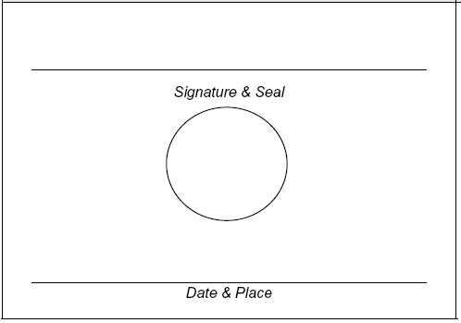

ATHLETE FIVB

NATIONAL FEDERATION OF THE ATHLETE NATIONAL FEDERATION HOSTING NATIONAL TOUR

